Contents

Steps to start the Backend Ecosystem 1

Steps to start the Frontend Ecosystem 2

# Steps to start the Backend Ecosystem

**Start Zookeeper and Kafka:**

Path: C:\Prosenjit\IT_Softwares\Kafka\kafka\bin\windows

start zookeeper.start bat (Default port = 2181)

cmd1: *zookeeper-server-start.bat ./../../config/zookeeper.properties*

start Kafka server (Default port = 9092)

cmd2: *kafka-server-start.bat ./../../config/server.properties*

**Start ELK:**

Path: C:\Prosenjit\IT_Softwares\ELK\7.6\elasticsearch-7.6.2\bin

cmd1: *elasticsearch.bat*

Path: C:\Prosenjit\IT_Softwares\ELK\7.6\kibana-7.6.2-windows-x86_64\bin

cmd2: kibana.bat

Path: C:\Prosenjit\IT_Softwares\ELK\7.6\logstash_7.6.2\bin

cmd3: logstash -f logstash.conf

Kibana Dashboard URL: <http://localhost:5601/app/kibana#/discover?_g=()&_a=(columns:!(_source),index:'39287ac0-dc3e-11ec-b804-3d9441ad63ab',interval:auto,query:(language:kuery,query:''),sort:!(!('@timestamp',desc)))>

Swagger URL: <http://localhost:52698/api/v1.0/market/swagger-ui/index.html#/>

(Change the port here from Eureka Server)

Eureka Server: <http://localhost:8762/>

Start the Apps in STS4:

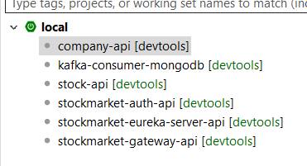

**Start Prometheus and Grafana:**

# Steps to start the Frontend Ecosystem

abc